SAMPLE MEDIA ALERT/CALENDAR LISTING
For Immediate Release
[MONTH DATE, YEAR]

JOIN [LIBRARY] FOR A NEW EXHIBITION, [EXHIBITION NAME]
Free, Hands-On Exhibition Coming [Start Date] Through [End Date]
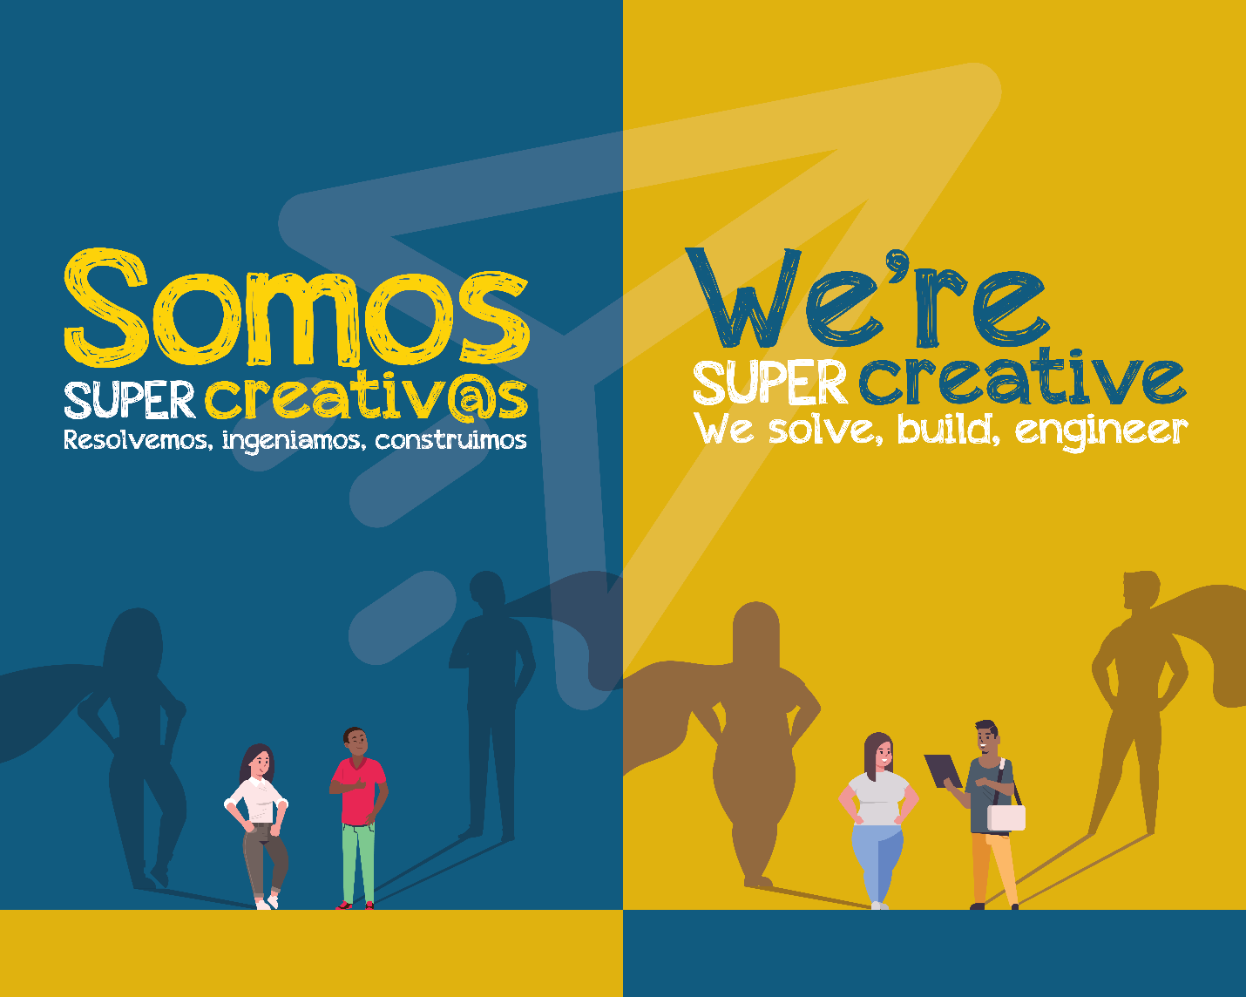

WHAT: Visit [LIBRARY] to get creative at “Somos Super Creativ@s: Resolvemos, ingeniamos, construimos/ We’re Super Creative: We solve, build, engineer,” a traveling exhibition where you can use technology to tell a story about your community and try an engineering design challenge. The exhibition is especially designed for tweens 10 to 13 years old and their families, but people of all ages will have fun learning and exploring Science, Technology, Engineering, Arts and Math (STEAM). The exhibition is written in both English and Spanish.

WHEN Be sure mark your calendar and join us for our [PROGRAM] on [DATE at TIME]!
“[EXHIBITION NAME]” is offered as part of the STAR Net STEAM Equity Project. [LIBRARY] is one of just 12 libraries nationwide selected to participate.
[START DATE to END DATE]. Visit the exhibition any time the library is open. Admission is free.

WHERE [LIBRARY ADDRESS; if applicable, include the room where the exhibition will be located]

WHO The STAR Net STEAM Equity Project is offered by the National Center for Interactive Learning at the Space Science Institute (NCIL/SSI), the American Library Association (ALA), Twin Cities PBS (TPT), Institute for Learning Innovation (ILI), and Education Development Center (EDC), with funding from the National Science Foundation (NSF).
This material is based upon work supported by the National Science Foundation under Grant Number DRL-1906172 to the Space Science Institute and Grant Number DRL-1906084 to the American Library Association. Any opinions, findings, and conclusions or recommendations expressed in this material are those of the authors and do not necessarily reflect the views of the National Science Foundation, Space Science Institute, or American Library Association.

CONTACT For more information and to view a calendar of related public programs at [LIBRARY], visit [LIBRARY WEBSITE] or call [PHONE NUMBER].

# # #

