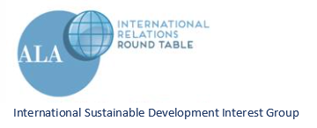
ISLD Meeting
ALA Annual Washington, D.C.
June 22, 2019
Present: Mary Lee Gaylor, Peter Deekle, Carolyn Ziering, Clara Chu, Kay Cassell, Pat Wand, Joan Weeks, Amed Demirhan, Jane Mirandette, Jill Gramling, Connie Champlin
- Peace Corps Affiliate Group
Has been created, needs more promotion
Pat will invite her Peace Corps museum group to join
Kay will submit an article for an upcoming issue of International LEADS explaining how to join
- ALA Annual 2019 Final Details
- Joan informed attendees of 2 open houses at the LOC during the conference
- ALA Annual 2020 Program
Librarians Without Borders – discuss experience in Guatemala per recent article in LEADS
Peter Deekle is Program Chair to be assisted by Connie and Carolyn
- Conference call 2nd week of August to finalize the Program Submission before deadline
- ISLD Website
Using a new “wireframe” concept – Sister Libraries is an example
- Conference call 3rd week of September to discuss website
- ALA Annual 2021 Program
Possible Program about the UMD-Nicaragua Makerspace Project
ISLD page: tinyurl.com/irrt-isld

