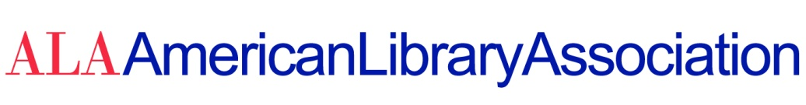

DATE: June 8, 2020

TO: ALA Council Members (2019-2020)

FROM: Marsha P. Burgess, Council Secretariat

RE: Division Annual Reports to the ALA Council

In accordance with ALA Policy A.4.2.5.5: “Annual reports from ALA division presidents shall be submitted to Council in writing for inclusion in the record of Council meetings.”

The following divisional reports are available at:

http://www.ala.org/aboutala/2020-division-annual-reports-ala-council

ALA CD#28.1 American Association of School Librarians (AASL)

ALA CD#28.2 Association of College and Research Libraries (ACRL)

ALA CD#28.3 Association for Library Collections and Technical Services (ALCTS)

ALA CD#28.4 Association for Library Services to Children (ALSC)

ALA CD#28.5 Association of Specialized & Cooperative Library Agencies (ASGCLA)

ALA CD#28.6 Library and Information Technology Association (LITA)

ALA CD#28.7 Library Leadership and Management Association (LLAMA)

ALA CD#28.8 Public Library Association (PLA)

ALA CD#28.9 Reference and User Services Association (RUSA)

ALA CD#28.10 Young Adults Library Services Association (YALSA)

ALA CD#28.11 United for Libraries (UFL)

