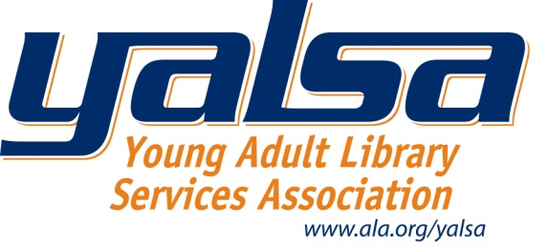

YALSA Online Course Registration

Use this registration form to register by mail, email or fax. Check, money order, purchase order or credit card must accompany registration to reserve space in this course. Mail or fax your registration form with payment to the address below. Fax registrations are accepted for credit card and purchase orders only.

American Library Association
ATTN: YALSA CE Registration
50 E. Huron Street
Chicago, Illinois 60611
(312) 280-5276 fax

Questions? Contact Nicole Gibby Munguia, Program Officer for Continuing Education at (800) 545-2433 ext. 5293

Any cancellations must be received in writing at YALSA by the latest registration deadline listed online and are subject to a $40 processing fee. Refunds will not be issued after the first week of the course has passed. Refunds will be processed two weeks after the start of the course. YALSA reserves the right to cancel a course for reasons including insufficient numbers of students.

REGISTRATION FORM

Please complete the following form by typing in your information or with legible print writing.

Course Name: ______________________________
Mailing Address: ______________________________
Member Number: ______________________________
First Name: ______________________________ Last Name: ______________________________

Org. Name: ______________________________
Address: ______________________________
______________________________
City: __________________ State: ____ Zip: _________

Phone: (______)_______-_______ (Work) (______)_______-_______ (Home) (______)_______-_______
Fax: (______)_______-_______ E-mail: _________________________________

Preferred mailing, if other than organizational address
Address: ______________________________
______________________________
City: __________________ State: ____ Zip: _________
___________________________________________________________________________________________
Registration Fee: Select one
____ $155 (YALSA Member) ____ $155 (students) ____ $195 (ALA members) ____ $215 (nonmembers)

Payment Method: Place a check mark in appropriate box
Check or Money Order (payable to the American Library Association)
Purchase Order (include a copy of the order with this form)

For credit card & purchase orders, please complete the following:

VISA
Master Card
American Express
Card/P.O. Number: ______________________________ Exp: _____/______
Name on Card/P.O.: ______________________________
Credit Card Security No.: ______________

Signature: ______________________________

