OPEN ENROLLMENT TOOLKIT

OE6 Resources and Suggested Messaging

Despite constant threats to dismantle or undermine the Affordable Care Act, the ACA marketplace is stable and will be open for business starting November 1. This toolkit provides resources and suggested messaging to help consumers understand their options and help them #GetCovered for 2019.

Why Outreach Matters
Consumers are more than twice as likely to complete enrollment when they work with an in-person assister. Yet, despite the effectiveness of the Navigator program, federal funding continues to be reduced - severely limiting the number of enrollment assisters available around the country. In addition to those cuts, the administration’s budget for outreach and advertising has been reduced by 90 percent compared to previous years.

That’s why we need all-hands-on-deck -- to spread the word about open enrollment, and help our friends, family and neighbors gain the peace of mind of knowing they’re covered should the unexpected happen. Let’s spread the word, and help consumers everywhere #GetCovered!

Keep it Simple: Top 5 Things to Know about Open Enrollment

- When: November 1, 2018 - December 15, 2018 (some states may extend their deadlines, but in order to have coverage that begins January 1, you must enroll by December 15)
- Where: HealthCare.Gov Always start with HealthCare.Gov. If your state uses their own website, HealthCare.Gov will guide you there. HealthCare.Gov or your state-based marketplace can only sell ACA plans, so you can rest easy knowing you’re getting a comprehensive plan that will be there for you when you need it.
- What: Comprehensive coverage at an affordable price. HealthCare.Gov plans must include key benefits like mental health care, maternity care, prescription drug coverage and hospitalization services. In addition to good coverage, most marketplace shoppers will qualify for a discount based on their income. Last year, more than 8 in 10 shoppers could get a plan for less than $100/month.
- Why: Peace of mind. Financial security. Access to comprehensive care. There are so many reasons to sign up for affordable, comprehensive coverage, join the millions who have gained health insurance thanks to the ACA!
- How: Enroll online, over the phone, or in-person. Log on to the official ACA marketplace at HealthCare.Gov, or CuidadodeSalud.Gov, call the marketplace call center at 1-800-318-2596, or make an appointment for in-person through the Get Covered Connector

Dispelling Myths

There’s a lot of confusion among both the remaining uninsured and current marketplace consumers about what exactly has changed, what hasn’t, and what are the best options for enrolling in coverage. We’re busting some of the most common myths about the ACA - check them out below.

Myth #1: Financial help to lower premiums and out-of-pocket costs is no longer available. FALSE. Financial assistance is still available for low and middle-income consumers to help lower the cost of their plan. In fact, more than 8 out of 10 consumers last year qualified for a tax credit.

Myth #2: The marketplace is not stable and premiums are skyrocketing. FALSE. In fact, premium price increases for 2019 are expected to be much lower than previous years, and some states will even see price decreases. CMS recently announced a national average drop of 1.5 percent in premiums across states using HealthCare.Gov.

Myth #3: I am no longer protected from discrimination for having a pre-existing condition. FALSE. All of the consumer protections created by the ACA are still intact, and all plans sold by HealthCare.Gov must provide comprehensive coverage, and cannot charge a consumer more because of their health status or medical history. Plans outside the ACA marketplace don’t have to offer the same protections, so always make sure to use HealthCare.Gov when enrolling in coverage.

Myth #4: Insurers are dropping out. FALSE. In fact, the highest number of insurers are participating this year since 2015. There will be 23 more insurers participating in HealthCare.Gov states and 29 insurers are expanding their coverage to additional counties in 2019 compared to 2018. Overall 58 percent of enrollees in all 39 states using HealthCare.Gov will have three or more insurers to choose from. That means more choices and competitive prices for consumers.

Tax Credits and Affordability

The ACA marketplace is designed to help consumers who don’t have health insurance through their employer or through a government program like Medicaid or Medicare afford individual coverage. To make sure coverage is affordable, most low to middle income shoppers will qualify for a discount based on their income to lower the cost of their plan. Last year, 85 percent of enrollees received a tax credit to lower their monthly premiums. And, 4.5 million Americans qualified for a $0 bronze plan - that means they could get a plan with no monthly premium!

If your annual income falls between 100 percent and 400 percent of the federal poverty line (FPL), you could qualify for a tax credit. And, if your income is less than 250 percent FPL, you could qualify for additional discounts that lower your out of pocket costs, like your deductible. Check out the chart below to see if you qualify:

FPL Chart for Calculating Tax Credits for 2019 Plan Year
Household Size | 100% FPL | 138% FPL | 250% FPL | 400% FPL
1 | $12,140 | $16,753 | $30,350 | $48,560
2 | $16,460 | $22,715 | $41,150 | $65,840
3 | $20,780 | $28,676 | $51,950 | $83,120
4 | $25,100 | $34,638 | $62,750 | $100,400
Source: http://www.healthreformbeyondthebasics.org/wp-content/uploads/2017/11/REFERENCEGUIDE_Yearly-Guidelines-and-Thresholds_2019.pdf

Key Messaging

The top messages partners and navigators have been using to encourage consumers to enroll in health coverage continue to be effective. Big awareness gaps remain among both the remaining uninsured and current marketplace enrollees. Most consumers are not aware of changes that may impact them and cost remains the fundamental barrier to coverage. Messages promoting low-cost plans and financial help, in-person help and the protection and comprehensive benefits one gets from being covered, continue to resonate. Below are some recommendations for messaging to the uninsured and currently enrolled this open enrollment period.

- Affordability is Key. Cost remains the biggest barrier to coverage and low awareness of the tax credit remains a big information gap.

More than 8 in 10 marketplace shoppers can get a tax credit to lower the cost of their plan

Discounts based on income are available to keep your health plan affordable

Last year, 4.5 million people could get a bronze-level plan without a premium

Plans and prices change every year, so it’s important to check out your options and see what’s available, even if you’ve looked before -- you might have a better deal than you expect.

- Get Peace of Mind: Comprehensive coverage & consumer protections haven’t changed. Promoting comprehensive coverage can help distinguish ACA plans from plans sold outside the marketplace, such as short-term plans, that provide fewer benefits and are not required to include consumer protections.

Plans offered at HealthCare.Gov cover comprehensive benefits like preventive care, check-ups, prescriptions, hospitalizations, mental health care, and more

When shopping for a plan on HealthCare.Gov, you cannot be charged more based on your health status

When enrolling in an ACA plan, you will never be asked about your medical history. The only factors that influence the price of your plan are your geography, age, and whether or not you are a smoker.

Accidents can happen anytime - get peace of mind knowing you’re covered if the unexpected happens. Enroll today at HealthCare.Gov.

- Consumers want in-person help. The focus group data found a surprising amount of consumers sought in-person help of some kind, indicating that most current enrollees and remaining uninsured would like expert guidance if it were available to them. While there is less in-person support than previous years, it’s important than consumers know what is available, and get connected to help where possible.

We know that when people meet with an in-person assister, they are nearly twice as likely to complete enrollment. Help consumers find help near them - find an appointment through the Get Covered Connector

- Deadlines! Like last year, the open enrollment period is shorter than it was the first four open enrollment periods. To make sure consumers don’t miss out, it’s very important to remind them of the December 15th deadline. Plan to ramp up communications in the final two weeks with e-blasts, social media posts, and other reminders about the December 15th deadline.

Open enrollment runs November 1 - December 15 in most states. Make sure folks know they MUST enroll by December 15 to have coverage for 2019!

December 15th, December 15th, December 15th!

Outreach and Education

We know it’s important to get the word out, and so we’ve compiled a variety of sample material for you to plug and play. For a full set of social media graphics, check out our OE6 materials here. To sign up for weekly emails providing suggested messaging, please reach out to Erin Hemlin at erin.hemlin@younginvincibles.org to join the National Get Covered Coalition listserv.

Social Media Strategy & Themed Weeks
Digital outreach is a cost-effective way to spread awareness about open enrollment and help connect consumers to coverage. In times where resources for direct outreach and education are dwindling, using social media and digital outreach can help us reach many more people with our key messages during open enrollment. This year, YI will be helping to facilitate “themed weeks of action” during open enrollment to provide constant opportunities to spread the word about OE6, and help consumers find coverage. Check out a snapshot of our open enrollment calendar below, and for a more detailed calendar, click here.

Week: | Theme / Community of Focus
Week 1: 11/4 - 11/10 | Provider Week of Action
Week 2: 11/11 - 11/17 | African American Week of Action
Week 3: 11/18 - 11/24 | Disabilities Week of Action, Thankful Week
Week 4: 11/25 - 12/1 | Faith Week, Rural Health Week of Action
Week 5: 12/2 - 12/8 | LGBTQ, AAPI, Latinx Weeks of Action
Week 6: 12/9 - 12/15 | Young Adult Week, Women’s Health Week

Sample Social Media Posts
We’ll be sharing out suggested messaging each week during open enrollment, but here’s a sample of general suggested messaging during open enrollment:

Top Hashtags: #GetCovered #EnrollByDec15

Facebook:
Need health insurance? It’s that time of the year again! And, good news this year, there are new plans available, which means more choices! Most shoppers will also qualify for financial savings to help lower their costs. But hurry, the deadline to sign up for coverage is December 15th! #GetCovered
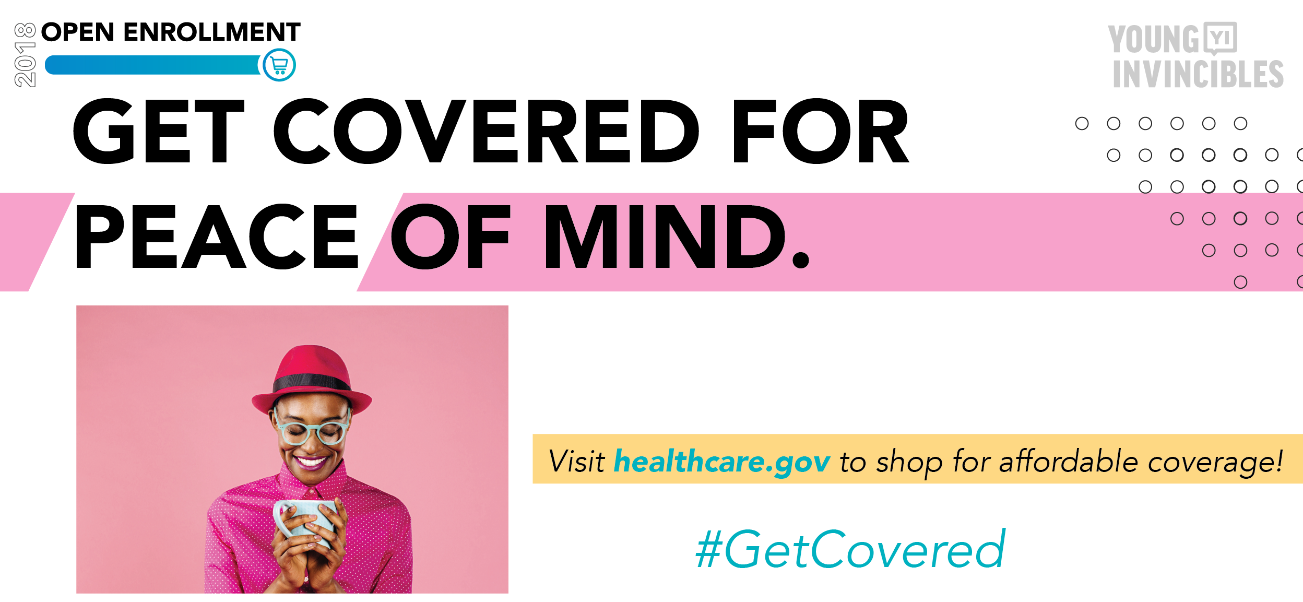

Twitter:
The open enrollment period to sign up for #ACA health coverage starts TODAY! Go to www.HealthCare.Gov to shop for a plan– more than 8 in 10 shoppers qualify for financial savings! But remember, you MUST #EnrollByDec15 #GetCovered

Sample Email Blast
One of the easiest ways you can help spread the word during open enrollment is by sending an e-blast to your network, reminding them to get enrolled and tell their friends. Below is a sample email you can use with your list that includes all the basic messaging mentioned above -- tailor to fit your audience, add in additional resources, or just send as is:

SUBJECT: Enroll in Health Coverage TODAY at HealthCare.Gov

Dear NAME,

Did you know it’s time to sign up for health coverage for 2019? If you need health insurance, you can enroll at HealthCare.Gov. But hurry, the deadline to enroll in a plan is December 15th - so don’t delay!

There’s a lot of confusion about the state of the Affordable Care Act (ObamaCare), but the truth is the ACA is still the law of the land, and comprehensive health coverage including key consumer protections like no discrimination against people with pre-existing health conditions, is still available to consumers who need to get covered.

Shop for a new health insurance plan on HealthCare.gov

Most marketplace shoppers will qualify for financial help to lower their costs, too. In fact, 85 percent of current enrollees receive a tax credit to help lower their monthly premiums, and most pay less than $100/month for their plan.

And this year, there are new plans available at new prices. Even if you’ve looked before, it’s important to check out your options - coverage might be more affordable than you think.

Already covered? Then help us spread the word about open enrollment and make sure your friends and family #getcovered too. There is far less support for outreach and advertising this year, so it’s up to all of us to get the word out. Ask your friends if they’re covered, post on social media, and remind everyone that December 15th is the final deadline to sign up for coverage in 2019. Go to HealthCare.Gov to enroll today!

To learn more about open enrollment and health coverage, check out WEBSITE.

Best,
NAME

Sign up for 2019 health insurance at HealthCare.Gov today!
Enroll November 1 - December 15, 2018

Insert Logo

The Affordable Care Act (ObamaCare) is still the law of the land! All plans sold on HealthCare.Gov MUST:
Offer comprehensive coverage
Include consumer protections (no discrimination against pre-existing conditions)
Offer discounts based on your income: 85 percent of enrollees qualify for financial savings

Coverage might be more affordable than you think.
More than 8 in 10 shoppers qualify for financial help to lower the cost of their plan.

Insert Logo

Need Help Enrolling in Coverage?

Expert, impartial assisters are available to help you in-person and over the phone. Call us at (XXX) XXX-XXXX or find an appoint at connector.getcoveredamerica.org

INSERT HOURS AVAILABLE INSERT HOURS AVAILABLE
ORGANIZATION NAME ORGANIZATION NAME
1234 STREET NAME 1234 STREET NAME
CITY, STATE ZIP CODE CITY, STATE ZIP CODE

Resources

Get Covered Connector: https://connector.getcoveredamerica.org/
Use the Connector to search by zip code and find an appointment in your area. To learn more about how to use the Connector as an assister, please reach out to Phelan O’Neill at phelan.oneill@younginvincibles.org

Community Catalyst Outreach Hub: https://drive.google.com/drive/folders/1XdQi210XQIl0Qtsgbs0B-kCwqrDsdp_l?usp=sharing Community Catalyst has created several social media graphics and flyers that are partners can use to spread the word about open enrollment

Young Invincibles OE6 Materials:
YI has created social media graphics and messaging that can all be found here.

In the Loop: Join the community of thousands of assisters to learn best practices, enrollment troubleshooting, and share updates.

Other Ways to Get Involved: Become a volunteer enrollment assister, sign up to make phone calls or send text messages, or find other ways of getting involved by reaching out to Erin Hemlin at erin.hemlin@younginvincibles.org

