Out2Enroll Partners,
Thank you for pledging to share information about this year’s 2019 open enrollment period to the LGBTQ people in your life. Together, we have made tremendous progress in advancing LGBTQ health: the uninsured rate among low- and middle-income LGBTQ people has dropped by an overwhelming 35% since 2013.
But there’s much more work to do this year to maintain and even build upon these gains—and a short timeframe to do it in since the open enrollment period is only 45 days and, like last year, ends on Dec. 15th. Your voice is more important than ever as the Affordable Care Act remains under attack from Congress and the Trump administration, which continues to slash budgets for advertising and in-person help. This means we all need to pitch in to get the word out.
Given these challenges, this work has never been more important. We’re thrilled to have you in the fight to make sure that LGBTQ people know their health insurance options, can find a plan they can afford, and know their rights when it comes to nondiscrimination in the health care system. If you care about LGBTQ health, now is the time to make sure more people than ever before enroll at HealthCare.gov.
Sending people directly to HealthCare.gov will be even more critical this year. This is because the Trump administration has touted non-Obamacare plans that do not cover preexisting conditions and will likely discriminate against our community. The Trump administration believes these plans are alternatives to the high-quality coverage you can find at HealthCare.gov, and we expect these non-Obamacare plans to be marketed aggressively to consumers (especially young adults). Making sure that we get the word out about HealthCare.gov can help our community avoid these junk plans and get the financial protection they deserve and expect.
To help you get the word out, we have developed open enrollment graphics, messaging, and sample social media posts we urge you to incorporate or draw from in the next two months. Thank you for joining Out2Enroll and partners across the country in making your voice heard!
Hashtags: #GetCovered, #EnrollByDec15, #BeOutBeHealthy, #KnowYourRights
Key Dates
- Oct. 29th: #MillennialMon Twitter chat on enrollment (3pm ET)
- Nov. 1st: Marketplaces open!
- Dec. 2nd to Dec. 8th: LGBTQ Enrollment Week of Action (more weeks of action here)
  - This week is also Latinx Week of Action and AAPI Week of Action, so there will be a lot of opportunities to engage!
- Dec. 3rd: #MillennialMon Twitter chat on LGBTQ health/enrollment (3pm ET)
- Dec. 5th: #WellnessWed Twitter chat on enrollment (2pm ET)
- Dec. 7th: National Youth Enrollment Day
- Dec. 10th: #MillennialMon Twitter chat on the enrollment deadline (3pm ET)
- Dec. 15th (Saturday): Final enrollment deadline* for 2019 coverage at healthcare.gov!
*Some states with their own marketplaces have extended their open enrollment periods, but the dates vary—please double check the enrollment deadline for your state’s marketplace.
CA | Oct 15, 2018 - Jan 15, 2019 | MA | Nov 1, 2018 - Jan 23, 2019 | RI | Nov 1, 2018 - Dec 31, 2018
CO | Nov 1, 2018 - Jan 15, 2019 | MN | Nov 1, 2018 - Jan 13, 2019
DC | Nov 1, 2018 - Jan 31, 2019 | NY | Nov 1, 2018 - Jan 31, 2019
Key Messages
In light of all of the confusion last year, message testing shows that the best messages are informational and demonstrate confidence and stability in the marketplaces. We must let people know that the marketplaces are once again “open for business” for 2019 coverage. To make it even easier this year, check out our week-by-week messaging guidance (attached and here). These messages are:
- “The marketplaces are open for business for 2019.” With Trump’s efforts to undermine the ACA, consumers are understandably confused about where things stand. Many continue to think that the ACA will be repealed even though average premiums are decreasing for the first time ever. Keep messaging apolitical, informative, and confident in the marketplace: “Healthcare.gov is open for business!” “You can still find health insurance that meets your needs and your budget.” and “You may qualify for a discount on health insurance in 2019.”
- “The final deadline to enroll is December 15th.” For consumers who use the marketplace, the open enrollment period has become normalized. This is just the way that many consumers shop for insurance—it is no longer new or unfamiliar—so messages that the marketplace is “open for businesses” and “it’s that time of year again” resonate with current consumers. These consumers may not, however, remember that the open enrollment period is shorter, so messaging around the Dec. 15th deadline remains critical to make sure these consumers don’t miss their opportunity to enroll.
- “Nothing has changed: LGBTQ people are protected from discrimination in health care and health insurance.” Although LGBTQ people are under attack by the Trump administration, it is important to remind the community that nothing has changed when it comes to health care. People still have access to financial help for health insurance and should continue to pay their premiums—and Section 1557’s nondiscrimination protections are still in place. Messages like “you should never face health discrimination simply for being who you are” resonate.
- “Health plans and prices change every year—and the amount of financial help you can get may change too. Visit HealthCare.gov today!” Affordability remains the biggest focus and challenge for returning consumers and the uninsured alike. Many simply won’t enroll if coverage costs too much. Financial help is also the best way to make a distinction between the marketplaces (since consumers can only get subsidies through HealthCare.gov). We recommend messages like “HealthCare.gov is the ONLY place you can get financial help” and “Even if you’ve looked before, it’s time to check out your options and find the plan that’s right for you.”
- “HealthCare.gov offers the most comprehensive coverage.” As noted above, we need to continue to regularly push HealthCare.gov as the ONLY place to find high-quality, affordable plans. Consider messages like “Make sure you’re getting the best plan - visit HealthCare.gov today” and “If you’re not visiting HealthCare.gov, you could be missing out on health insurance that covers everything you need.” In addition, you could use “Plans offered at HealthCare.gov cover comprehensive benefits like preventive care, check-ups, prescriptions, mental health care, birth control, and more.”
- “HealthCare.gov offers free help and personal assistance.” Consumers are far more likely to enroll if they receive in-person help, and 80% of LGBTQ people want to meet with an assister that understands LGBTQ-specific issues. Consumers can find free in-person help using our locator tool: http://www.out2enroll.org/enrollment-help. Messages that work well include “signing up is easy” and “you can get free LGBTQ-friendly help from an expert.”
- “Health insurance is better than ever for transgender people who can expect more and demand more.” Too few trans people have had real health insurance options because of discriminatory exclusions. But the ACA’s protections still apply to 2019 health insurance plans, so marketplace plans should NOT have transgender exclusions. Trans consumers should enroll and expect that transition-related health care will be covered. Trans people may still have to fight with their health insurance company by filing an appeal, but if they’ve been holding out, this is the year to enroll.

Printable Materials
These print-ready postcards are available here. Feel free to print them yourself or let us know (ben@out2enroll.org) what you’d like and we’ll print and send them to you for free!

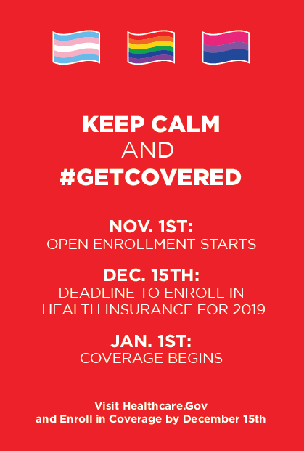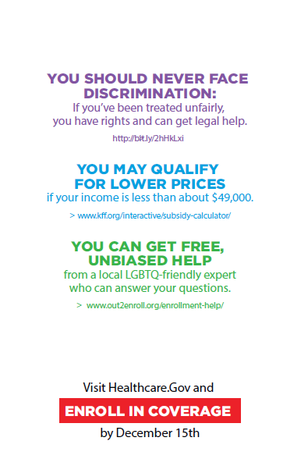
Social Media Shareables
These social media shareables and other images are available here. Many of this year’s materials are unbranded, making it easier for any organization to use them freely. We also plan to update the Google drive on a regular basis to add more graphics as they are developed.
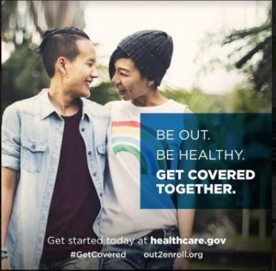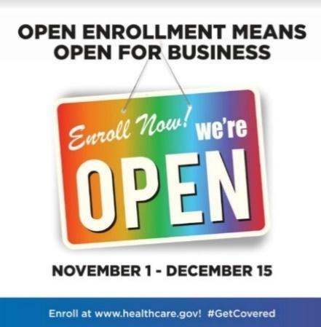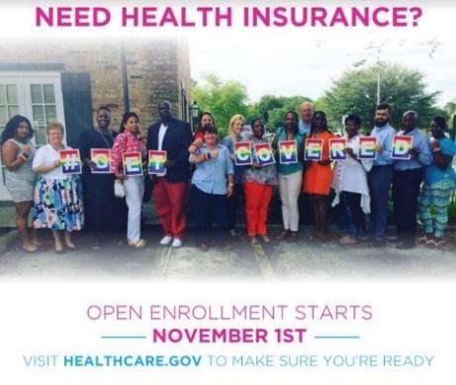

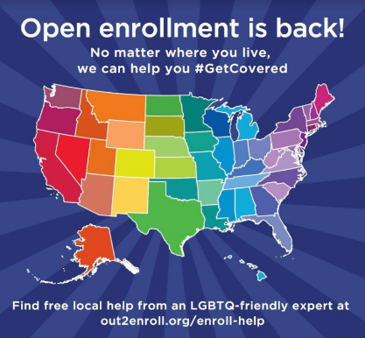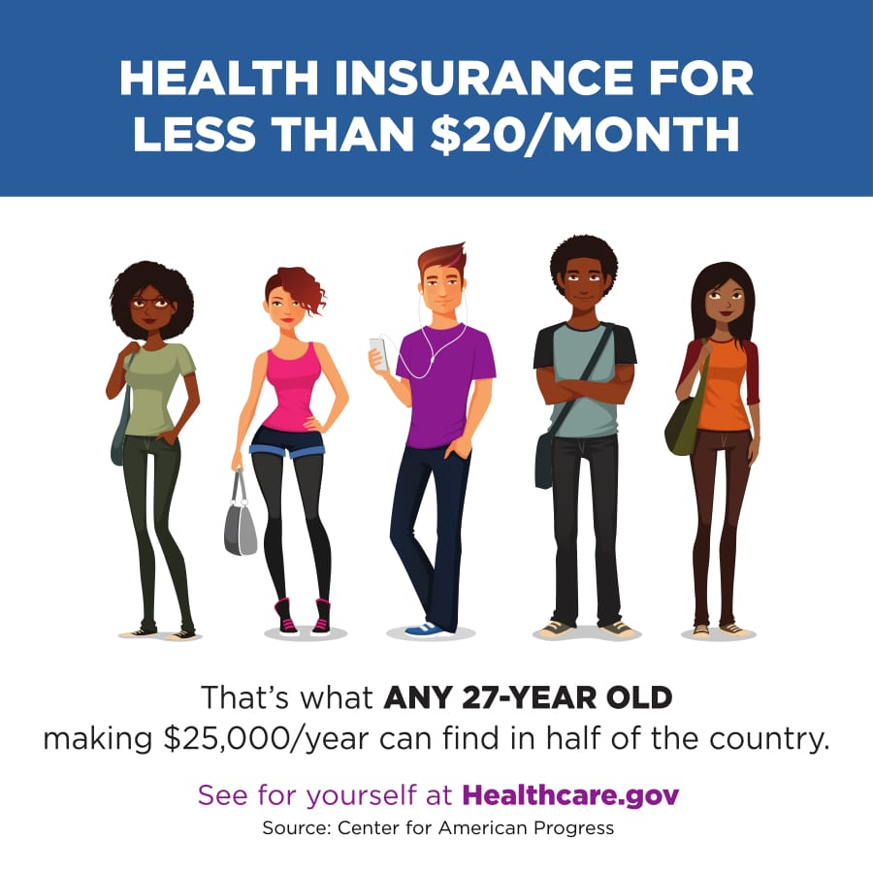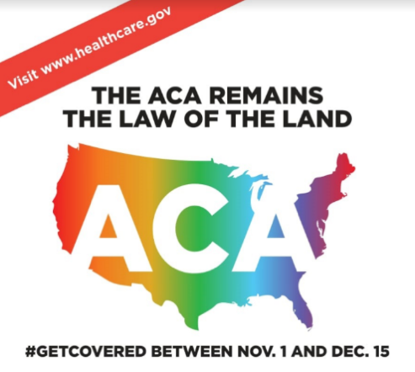

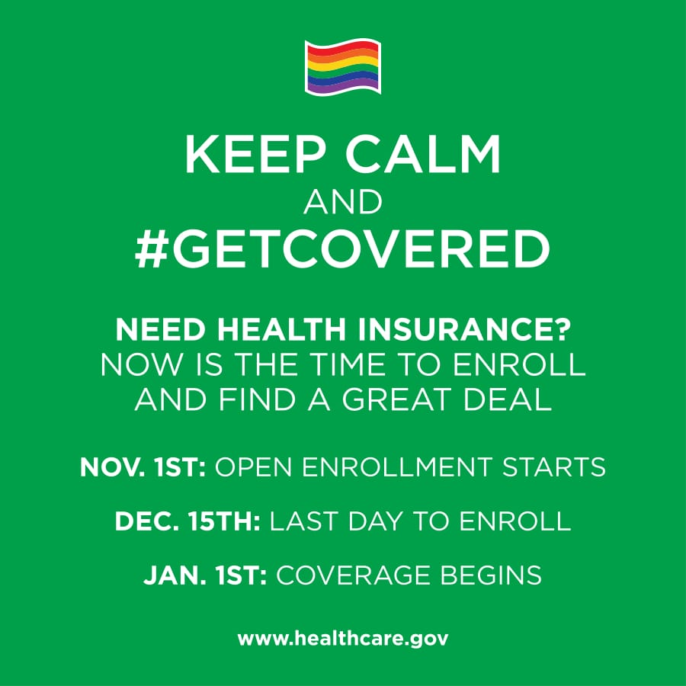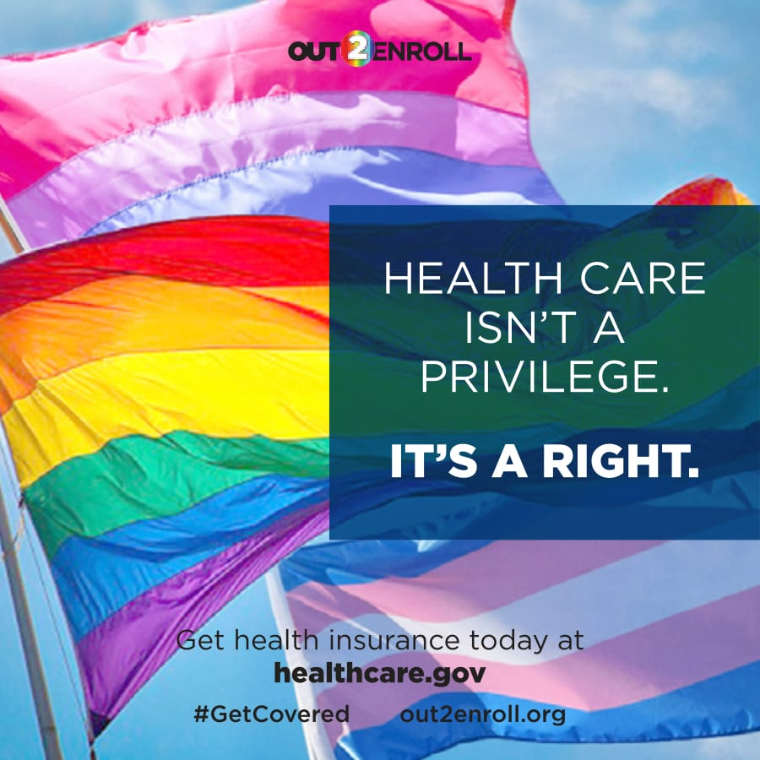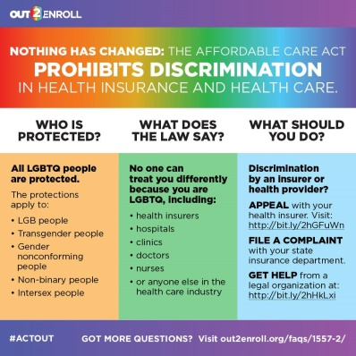

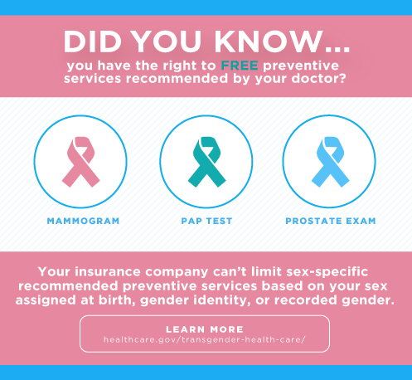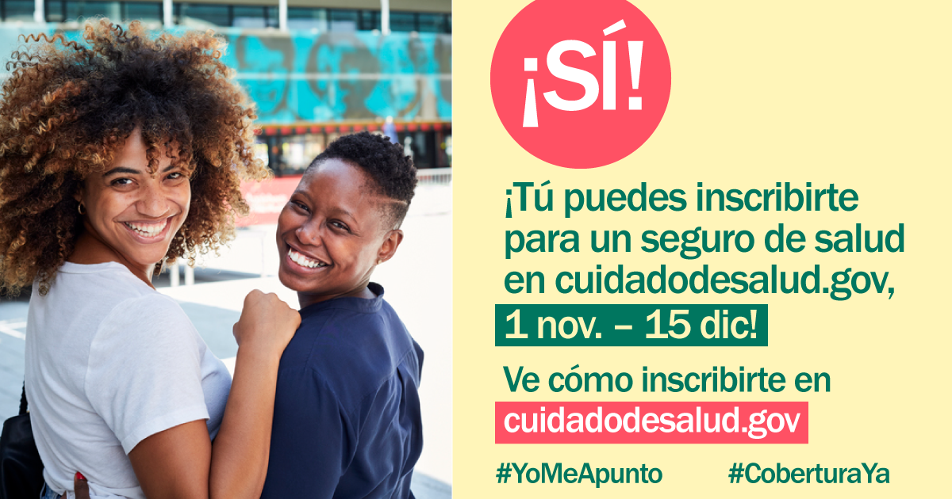

Sample Social Media Posts
“The marketplaces are open for business for 2019.” Hashtags: #EnrollByDec15 #ReadySetEnroll
- Open enrollment is BACK and HealthCare.gov is open for business! Do you qualify for lower prices on health insurance for 2019? Visit HealthCare.gov NOW to explore your options and #GetCovered! #EnrollByDec15
- It’s that time of year again – open enrollment is back! From now until Dec. 15th, you can find health insurance that fits your needs and your budget for 2019. Visit HealthCare.gov today to see if you qualify for a discount #GetCovered #EnrollByDec15
- Got questions about health insurance? We’ve got you covered – Go to HealthCare.gov TODAY to shop for health insurance that works for you. Make sure you and your loved ones #GetCovered before the December 15th deadline #EnrollByDec15
- Open enrollment is ON! Shop for health insurance that fits your budget and your life. Visit HealthCare.gov, check out your options, and #EnrollByDec15 so you start 2019 off right #ReadySetEnroll #GetCovered
- Millions now have health insurance thanks to the Affordable Care Act, including many LGBTQ people. Make sure you #GetCovered at HealthCare.gov before the December 15th deadline #EnrollByDec15
- HealthCare.gov is OPEN for business with new plans and new prices! #GetCovered TODAY before the Dec 15 deadline! #EnrollByDec15
- Open enrollment means open for ALL, including LGBTQ people and families! Spread the word and #GetCovered at HealthCare.gov before it’s too late #EnrollByDec15

“The final deadline to enroll is December 15th.” Hashtags: #EnrollByDec15 #GetCovered
- DYK: the final deadline to get health insurance for 2019 is on Dec. 15th?!? Make sure you get the coverage you need before it’s too late. Don’t put it off – visit HealthCare.gov TODAY #EnrollByDec15
- HealthCare.gov is open for business for 2019 – but only until Dec. 15th. Give yourself peace of mind by visiting HealthCare.gov today #EnrollByDec15
- Tick tock, tick tock…we’re getting closer to the FINAL DEADLINE to enroll in health insurance. The LAST DAY is Dec. 15th – so don’t miss your chance! Visit HealthCare.gov today to get started and give yourself peace of mind #EnrollByDec15
- DYK the FINAL deadline to get health insurance for 2019 is on Dec. 15th? #GetCovered TODAY at HealthCare.gov #EnrollByDec15
- Don’t delay, enroll today! The deadline is Dec. 15th but you can avoid the rush and #GetCovered TODAY at HealthCare.gov #EnrollByDec15
- Nobody likes waiting in line. Avoid the rush by signing up for health insurance TODAY at HealthCare.gov. #GetCovered #EnrollByDec15
“Health plans and prices change every year—and the amount of financial help you can get may change too.” Hashtags: #EnrollByDec15 #GetCovered
- Worried about costs? Health plans and prices change every year and you could SAVE BIG. Sign on to HealthCare.gov to check out your options and find a deal TODAY #GetCovered #EnrollByDec15
- Health insurance can be expensive – but it doesn’t have to be! HealthCare.gov is the ONLY place you can get a discount on your health insurance. See if you qualify and shop around for the best deal #GetCovered #EnrollByDec15
- Health insurance is cheaper than you think – head to HealthCare.gov today to SHOP and SAVE on health insurance for 2019! #GetCovered #EnrollByDec15
- Do you qualify for a discount on health insurance? Most people do! Visit HealthCare.gov TODAY to see how affordable it is for you to #GetCovered. #EnrollByDec15
- Enrolling in health insurance is cheaper & easier than you think! Visit HealthCare.gov now to SHOP & SAVE for 2019! #EnrollByDec15
- Health insurance doesn't have to break the bank - visit HealthCare.gov today to see if you qualify for a discount! #EnrollByDec15

“HealthCare.gov offers free help and personal assistance.” Hashtags: #EnrollByDec15
- Need help finding health insurance? Worried about how much it will cost? You're not alone! Connect today with a FREE LGBTQ-friendly expert to make sure you're getting the best deal on coverage. Visit out2enroll.org/enrollment-help and #EnrollByDec15 at HealthCare.gov.
- Getting health insurance is easier than ever at HealthCare.gov! But if you've still got questions, find a FREE in-person LGBTQ-friendly assister in your area. Make an appointment today at out2enroll.com/enrollment-help and #GetCovered before it’s too late! #EnrollByDec15
- Only [X] more days to #GetCovered at HealthCare.gov! If you need a little help, we've got your back! Free in-person or over-the-phone experts are available at out2enroll.org/enrollment-help #EnrollByDec15
- No need to stress about health insurance – we can help! Free queer-friendly help is available at out2enroll.org/enrollment-help! #EnrollByDec15 at HealthCare.gov.
- Ready to shop for health insurance at HealthCare.gov? Need extra help? Visit out2enroll.org/enrollment-help to talk to a FREE LGBTQ-friendly expert to help you #GetCovered #EnrollByDec15
- Need answers to your trans-related health insurance questions before you choose a HealthCare.gov plan? We can help! Connect for FREE with a trans-friendly expert at out2enroll.org/enrollment-help and #EnrollByDec15

“LGBTQ people are protected from discrimination in health care and health insurance.” Hashtags: #EnrollByDec15 #KnowYourRights
- We know the headlines can be scary when it comes to health care and being LGBTQ. But our community is still protected from discrimination in health insurance, at the hospital or clinic, and with our doctors. You should never be disrespected simply for being who you are #KnowYourRights and enroll in health insurance at HealthCare.gov before it’s too late #EnrollByDec15
- Got questions about your rights in health care? Nothing has changed—the Affordable Care Act STILL protects all LGBTQ people from discrimination in health insurance and health care. Enroll now at HealthCare.gov before it’s too late #EnrollByDec15 #KnowYourRights
- You should never face discrimination for being who you are. Enroll in health insurance at HealthCare.gov TODAY knowing that health insurance companies can’t discriminate against you for being LGBTQ #KnowYourRights #GetCovered #EnrollByDec15
- All LGBTQ people are protected from discrimination in health insurance and health care. What does that mean? Learn more at out2enroll.org/category/faqs/discrimination/ and #GetCovered at HealthCare.gov before Dec. 15th #KnowYourRights #EnrollByDec15
- You should NEVER face discrimination no matter who you are or where you live. Enroll with confidence at HealthCare.gov #EnrollByDec15

“Health insurance is better than ever for transgender people who can expect more and demand more.” Hashtags: #EnrollByDec15 #KnowYourRights #TransHealth
- #TransHealth matters! Thanks to the ACA trans & GQ ppl are protected from discrimination in health insurance & care. That means access to the transition-related care you need & the right to be treated w/ respect. #KnowYourRights & #EnrollByDec15 at HealthCare.gov
- We know it can be frustrating to find the health insurance you need, especially for transition-related care. But marketplace plans are better than ever before. Enroll with confidence at HealthCare.gov - before it’s too late #KnowYourRights #EnrollByDec15
- Nondiscrimination protections for #LGBTQ people mean NO #trans exclusions & better coverage. Enroll with confidence at HealthCare.gov. #EnrollByDec15
- You have the right to the care you need and the respect you deserve, especially when it comes to #TransHealth #GetCovered TODAY at HealthCare.gov. #EnrollByDec15

