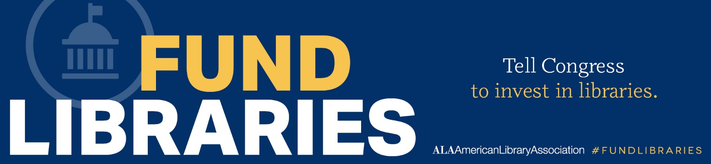

FEDERAL FUNDING FOR LIBRARY PROGRAMS: FY 2020-2024
AGENCIES AND PROGRAMS BY APPROPRIATIONS BILL | FY 2023 | FY 2024 | FY 2025
 | Final | Final | President's Request
Subcommittee on Labor, Health and Human Services, Education, and Related
Museum and Library Services Act of 2018 (PL 115-410)
Institute of Museum and Library Services (IMLS) | 294,800 | 294,800 | $280,000
}Library Services and Technology Act of 2018 (PL 115-410) | $211,050 | $211,050 | $203,250
}Grants to State Library Agencies | $180,000 | $180,000 | $177,200
}Native American Library Services | $5,800 | $5,800 | $5,236
}National Leadership: Libraries | $15,300 | $15,300 | $12,787
}Laura Bush 21st Century Librarian | $10,000 | $10,000 | $8,000
Every Student Succeeds Act of 2015 (PL 114-95)
}Comprehensive Literacy Development Grants (formerly Striving Readers) | $194,000 | $194,000 | $194,000
}Innovative Approaches to Literacy (Under FIE) | $30,000 | $30,000 | $30,000
}Title I - Grants to Local Educational Agencies | $18,387,000 | $18,407,000 | $18,587,000
} Title II - Supporting Effective Instruction | $2,190,000 | $2,190,000 | $2,190,000
}Title IV Part A (ESSA: Well Rounded Education; created 2016) | $1,380,000 | $1,380,000 | $1,380,000
}Nita Lowey 21st Century Community Learning Centers | $1,330,000 | $1,330,000 | $1,330,000
Carl D. Perkins Career and Technical Education Act of 2006 (PL 109-270)
}Career and Technical Education State Grants | $1,430,000 | $1,440,000 | $1,470,000
}Adult Education State Grants | $729,000 | $729,000 | $734,000
}Adult Education National Leadership Activities | $13,712 | $13,712 | $187,100
Education Sciences and Reform Act (PL 107-279)
}Assessment and NAEP (IES) | $193,000 | $193,300 | $193,300
}Research, Development and Dissemination (IES) | $245,000 | $245,000 | $245,000
}Educational Statistics (IES) | $122,000 | $122,000 | $122,000
Medical Library Assistance Act of 1965 (PL 89-291)
}National Library of Medicine (NIH) | $497,548 | $497,548 | $526,800
Postsecondary Education
}Federal Work Study | $1,210,000 | $1,230,000 | $1,230,000
}Federal Supplemental Ed. Opportunity Grants (SEOG) | $910,000 | $910,000 | $910,000
}Aid for Hispanic Serving Institutions (Title V, Parts A&B) | $255,000 | $256,000 | $276,000
}Federal TRIO Programs | $1,191,000 | $1,191,000 | $1,211,000
}Strengthening HBCUs | $396,000 | $401,000 | $432,000
Subcommittee on Legislative Branch
Library of Congress | $828,548 | $852,158 | $855,000
}National Library Service for the Blind and Print Disabled | $60,000 | $66,130 | $59,000
Government Publishing Office | $130,249 | $131,999 | $145,000
Subcommittee on Financial Services and General Government
National Archives and Records Administration | $428,000 | $427,250 | $455,000
}NHPRC Program Grants | $13,000 | $10,000 | $35,000
Subcommittee on Interior and Environment
National Endowment for the Arts | $207,000 | $207,000 | $210,100
National Endowment for the Humanities | $207,000 | $207,000 | $200,000
Compiled by the American Library Association ($ in thousands)

