**Your public library…**

* is a free, safe community space where programs, information and resources are available to **everyone**;
* has family literacy programs for babies, toddlers, and preschoolers with their parents or caregivers;
* helps people of all ages reach their potential as students, workers, parents, and community members;
* provides information literacy training;
* has high-quality programs for children and teens;
* offers homework help; and
* has access to resources to help families live and thrive.

**As an educator, by working with your local library you can…**

* have access to a wide range of books and materials FOR FREE;
* make use of your local librarian’s expertise as an information professional;
* share ideas and experiences and learn from one another; and
* provide a better service to the community.

*\*Adopted from the California Library Association at* <http://www.cla-net.org/displaycommon.cfm?an=1&subarticlenbr=203> accessed on 11/12/2013

**Public libraries are essential partners in providing early literacy education. Through providing materials and programs, they play a key role in helping children become ready to read and preparing children for school.  They have a long history of supporting educators and families and are cherished by many community members. Consider partnering with your local library to help support early learning and literacy in your community.**

The Association for Library Service to Children (ALSC) supports the following national early literacy initiatives – Ask your local library if they are working on any of these initiatives and find out how you can work together, today.

Read! Build! Play! seeks to bring reading-focused activities nationwide. Designed for children five and younger, RBP blends early reading with construction play, encouraging youngsters to build along as their parents/librarians read simple, age-appropriate books. ALSC and LEGO DUPLO© are dedicated to promoting the importance of play in early learning.

Learn More at:

**http://readbuildplay.com**

readbuildplay.jpg

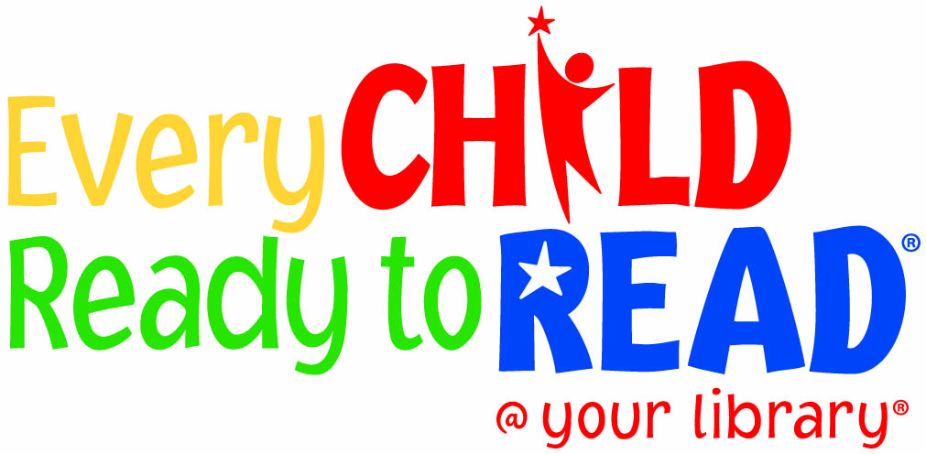  


  


*ECRR is administered in partnership with the Public Library Association.

*RBP is administered in partnership with LEGO DUPLO®.

*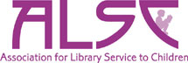The Association for Library Service to Children (ALSC)*, a division of the *American Library Association (ALA)*, is the world’s largest organization dedicated to the support and enhancement of library service to children. From creative programming and best practices to continuing education and professional connections—ALSC members are innovators in the field of children's library service. To learn more about ALSC visit **http://ala.org/alsc.**