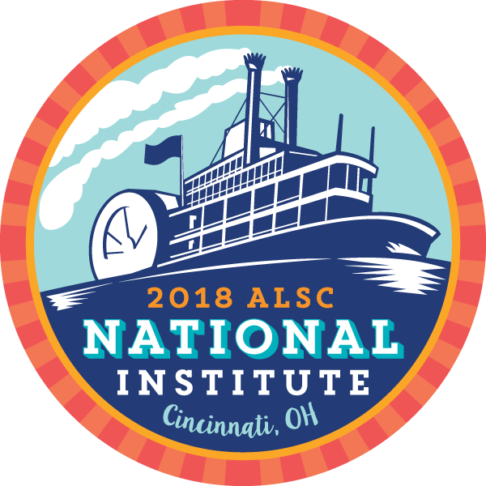

ALSC Advocacy and Access
Erin Silva & Angela Pilkington

Articles
​Library Journal 30 September 2016
http://lj.libraryjournal.com/2016/09/library-services/iowa-city-pl-institutes-autism-accessible-browsing-hour/
Webjunction 07 October 2016
http://www.webjunction.org/news/webjunction/autism-accessible-browsing-icpl.html

Chicago Tribune 25 April 2017
http://www.chicagotribune.com/suburbs/northbrook/news/ct-nbs-northbrook-library-access-tl-0216-20170211-story.html
AL Direct 20 September 2016
https://americanlibrariesmagazine.org/al-direct/archive/
http://publiclibrariesonline.org/2015/06/special-access-browsing-for-kids-with-autism-spectrum-disorder/
​​http://librariesandautism.org/articles.htm

Links
Gluten-Free playdough recipe
http://www.thechaosandtheclutter.com/archives/gluten-free-candy-cane-playdough

"Calm-down" bottles
http://www.preschoolinspirations.com/6-ways-to-make-a-calm-down-jar/

Water Beads
https://www.amazon.com/dp/B01DQ415GE?psc=1

Fun & Function
https://funandfunction.com/

TheraBands
https://www.amazon.com/TheraBand-Professional-Non-Latex-Resistance-Exercise/dp/B01MT58UUT/ref=sr_1_2?ie=UTF8&qid=1493653252&sr=8-2&keywords=thera+bands

Fidget Discs
https://www.amazon.com/fit-Inflatable-Stability-Exercises-Inflation/dp/B000TQ84TE/ref=sr_1_2?ie=UTF8&qid=1493653354&sr=8-2&keywords=fidget+discs

Balance Balls for kids
https://www.amazon.com/Gaiam-Kids-Stay-N-Play-Balance-Ball/dp/B00WQIV96S/ref=sr_1_1?ie=UTF8&qid=1493653414&sr=8-1&keywords=balance+balls+for+kids

​Visual schedule for storytime
Do2Learn (http://do2learn.com/)
This site has some great picture cards for making visual schedules. Clip art also works fine.

Sensory Storytimes
http://www.alsc.ala.org/blog/2012/03/sensory-storytime-a-brief-how-to-guide/

Libraries and Autism
​http://librariesandautism.org/strategies.htm

Other Helpful sites
Libraries and Autism
http://librariesandautism.org

Autism Society of Iowa
http://autismia.com/

This video was made by Dimensions, a care group from the UK.
https://www.youtube.com/watch?v=BJLbbJW1BpA&feature=youtu.be
ASAN (Autistic Self-Advocacy Network)
http://autisticadvocacy.org/

DJ Savarese
https://www.deejmovie.com

Iowa City Autism Community
http://autismiowacity.org/

Autistikids
http://www.autistikids.com/

